**CURRICULUM VITAE**

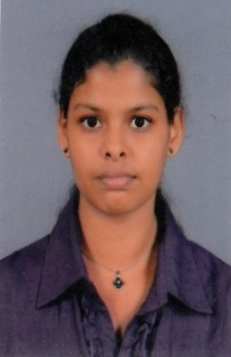

**A.A. Anusha Madushani Amarasinghe**

Contact Details : Mobile : 0711- 918 144

E Mail : anushiamarasinghe94@gmail.com

Address : No- 59/2, Meewala, Ruggahavila

Name In Full : Amarasinghe Arachchige Anusha Madushani Amarasinghe

Date Of Birth : 15.02.1994

Civil Status : Single

National ID No : 945463520 V

Nationality : Sri Lankan

**PROFESSIONAL PROFILE**

* To utilize my skills and experience to maximize my career potential and profitability of the organization.

**PERSONAL PROFILE**

* A result oriented individual with excellent work ethics.
* Possess excellent interpersonal and event organizing skills.
* Good judgment.
* Customer focused and confident when working with people of all levels.
* Able to multi-task in a fast-paced environment.
* Ability to communicate clearly.
* Interviewing skills is one of my strengths in HR.
* Self-confidence.
* Creativity.

**CAREER RECORD**

* Account Clerk - Bairaha PLC
* From : 01.04.2014 To : 01.11.2015

**ACADEMIC & PROFESSIONAL QULIFICATON**

* Reading an external degree of university of Sri Jayawardhanapura.
* Diploma in English
* Diploma in Computer Application Assistant
* Successfully Completed the Certificate Course in HRM at IPM

**G.C.E A/L 2013 at Yasodara Devi Balika Vidyalaya Gampaha**

( Ex.No- 7345518 )

***Subject Grade***

1. Business Studies A
2. Accounting B
3. Economics C
4. General English C

**G.C.E O/L 2010 at Yasodara Devi Balika Vidyalaya Gampaha**

( Ex.No- 60468157 )

***Subject Grade***

1. Sinhala A
2. Buddhism A
3. Mathematics A
4. English A
5. Commerce A
6. Drama & Theater A
7. Science B
8. History B
9. Home Science B

**EXTRA CURRICULAR ACTIVITIES**

At School

* The member of the commerce committee

**RFEREES**

1. Name : Mr. S.P Kumaradasa

Designation : Group Manager ( personnel & Administration )

Organization Address : Bairaha Farms PLC,

No 64/1, Green Park,

Nittambuwa.

Mobile : 077-3936766

1. Name : Mr. S.R Dinesh Gunathilaka,

Designation : HR Officer

Organization Address : Bairaha Farms PLC,

No 64/1, Green Park,

Nittambuwa

Mobile : 077-2366123

I hereby certify that the above particulars are true and correct to the best of my knowledge, and given the opportunity I would strive hard to exceed your expectations.

Date : 02.10.2015 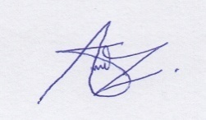 Signature